**Project - Weather Trends**

**Johannes Asbahr**

SQL queries used to get the data:

SELECT * FROM city_list WHERE city_list.country = ‘Germany‘ 🡪 nearest city is Hamburg

SELECT * FROM city_data WHERE city_data.city = ‘Hamburg‘

SELECT * FROM global_data

After i collected the data, i copied the global data to Hamburg’s data and calculated moving averages for both of them in new columns:

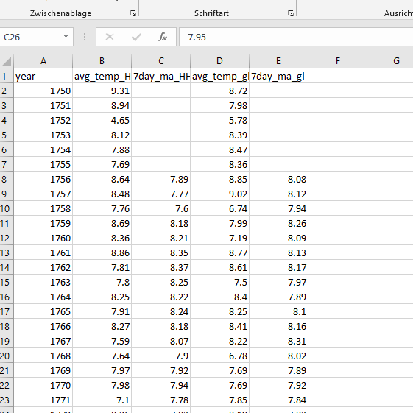

I did so, to use the csv file as a dataframe with Python. After that I converted the columns year, 7day_ma_HH and 7day_ma_gl to_numpy (needed arrays) to use them for matplotlib.

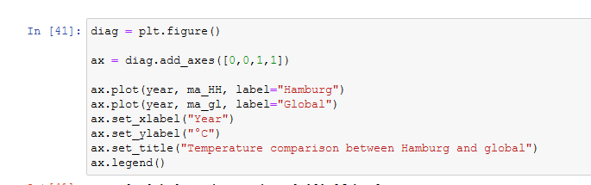

That way i could create a line chart with matplotlib.

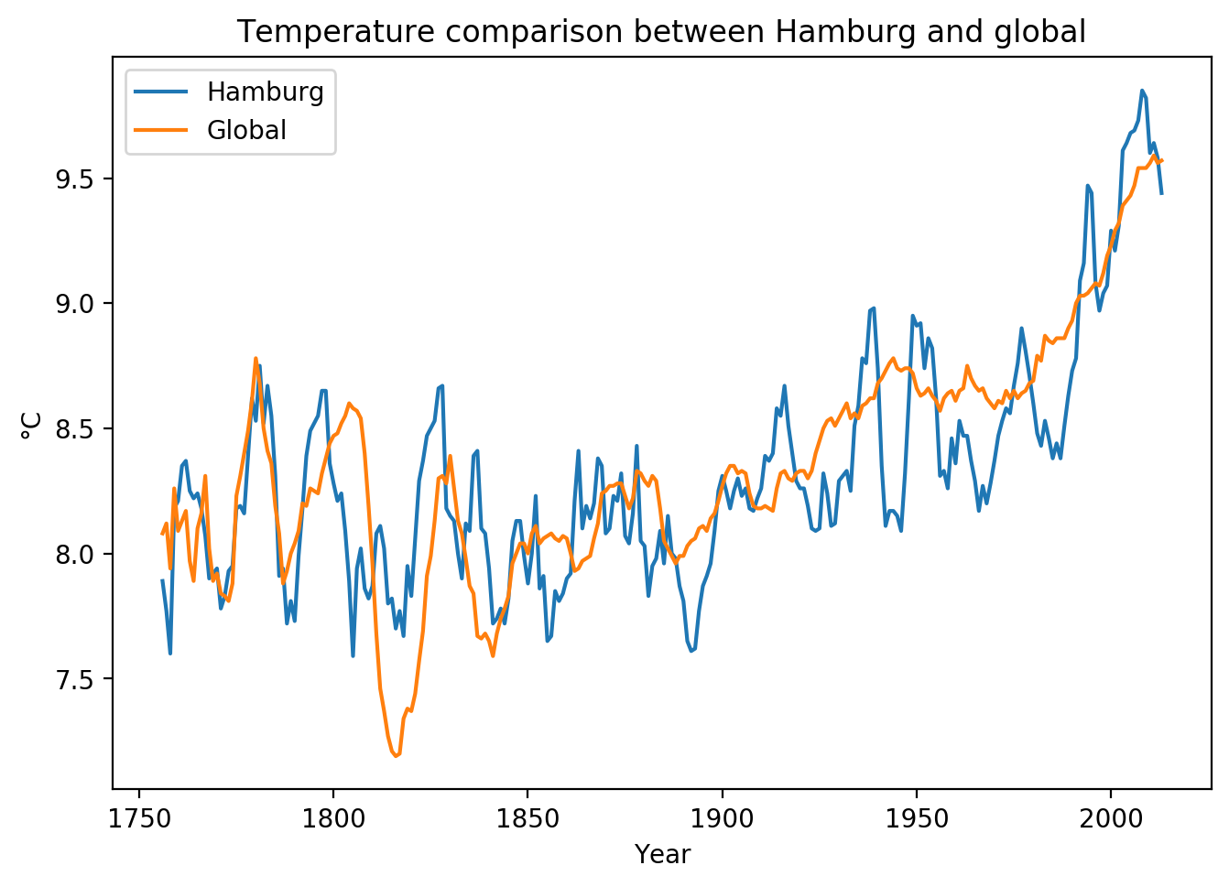

Observations:

* The difference in temperature in Hamburg seems to be more volatile over the last 250 years than the global average
* But overall the global temperature and Hamburg’s temperature are very close to another (no difference bigger than 1°C)
* Temperature is trending up since around 1900, since around 1970 the rise in temperature was even steeper than in the years before
* The global temeprature had a steep dip around 1815, temperature in Hamburg did not